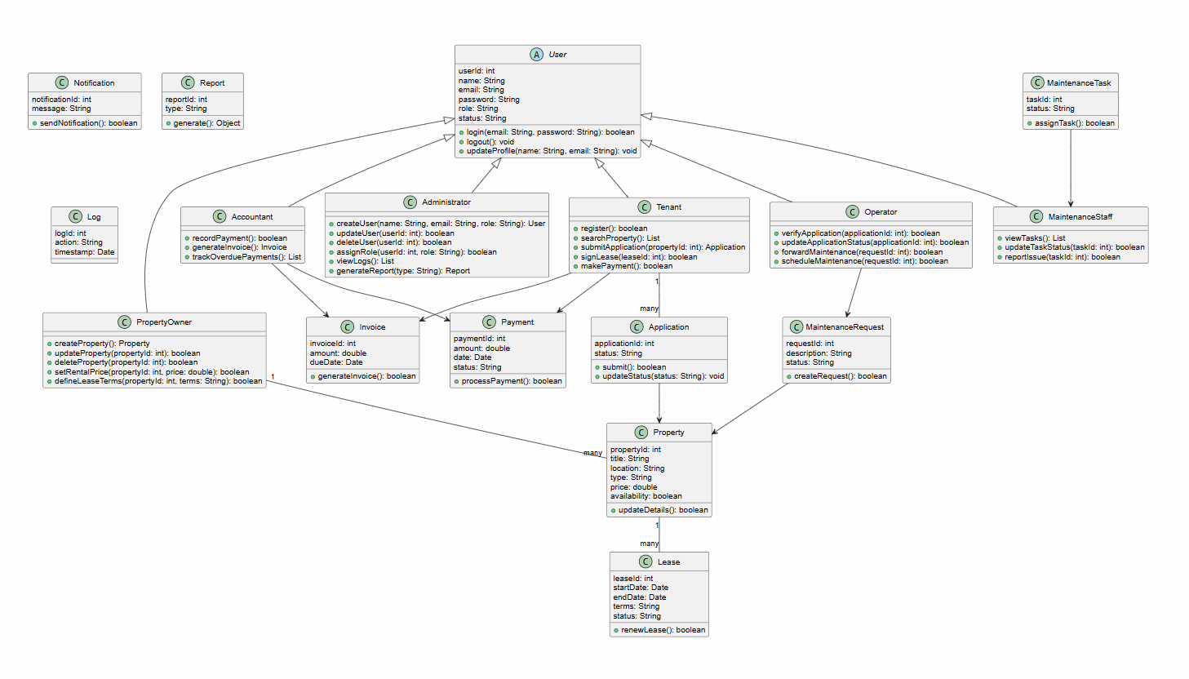
Class diagram:

Sofika Mamillo

Sequence Diagrams:

SQ001- Manage user accounts:
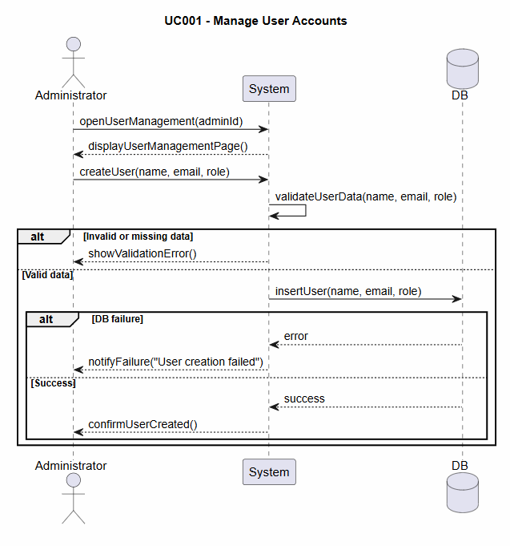
Megi Mara

SQ002- Assign and update roles and permissions: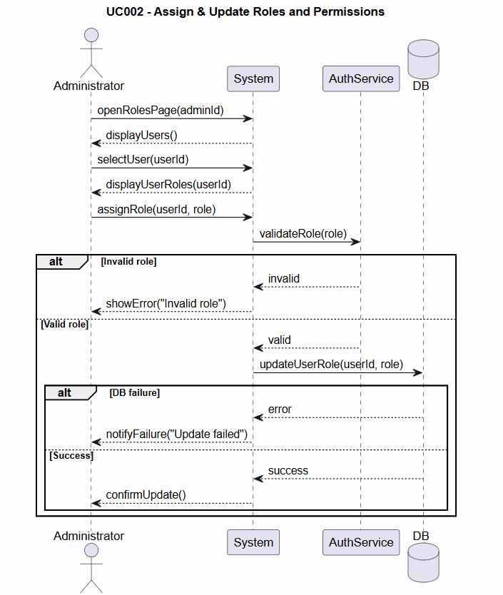
Megi Mara

SQ003- Manage system settings and configurations

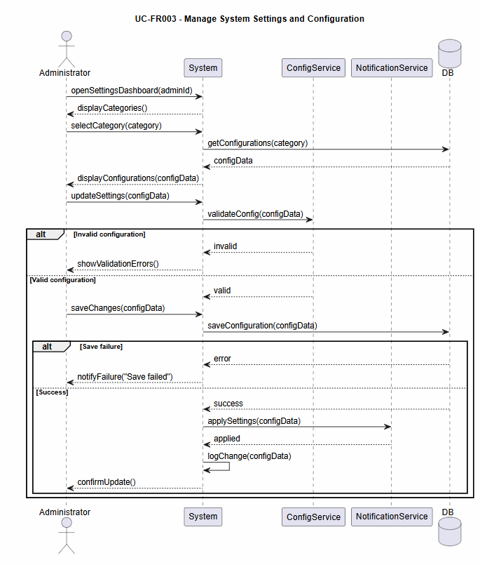

Megi Mara

SQ004- Monitor system usage and activity

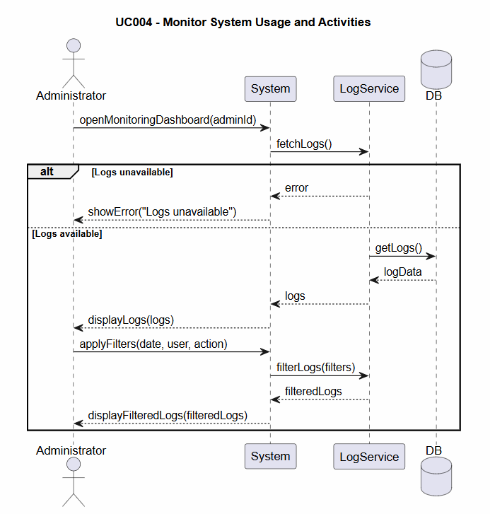

Megi Mara

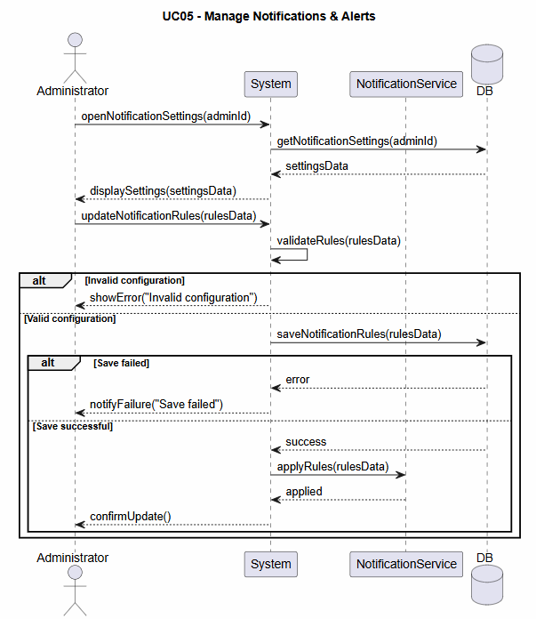
SQ005- Manage notifications and alerts

Gerald Mekshi

SQ006- Receive Alerts and errors:

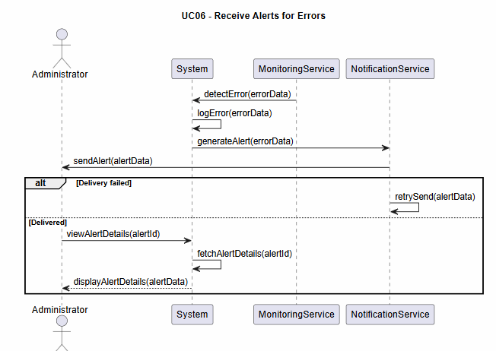

Gerald Mekshi

SQ007- Generate System Reports
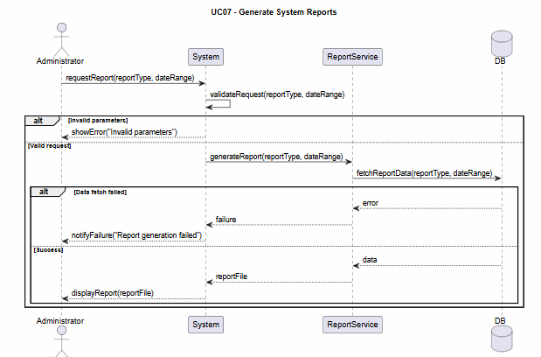

Gerald Mekshi

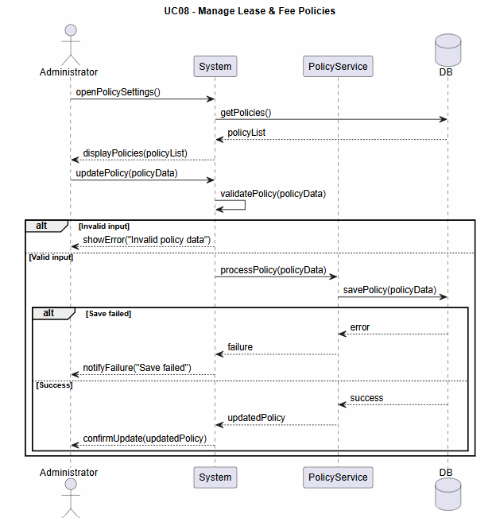
SQ008- Manage Lease and Fee Policies:

Gerald Mekshi

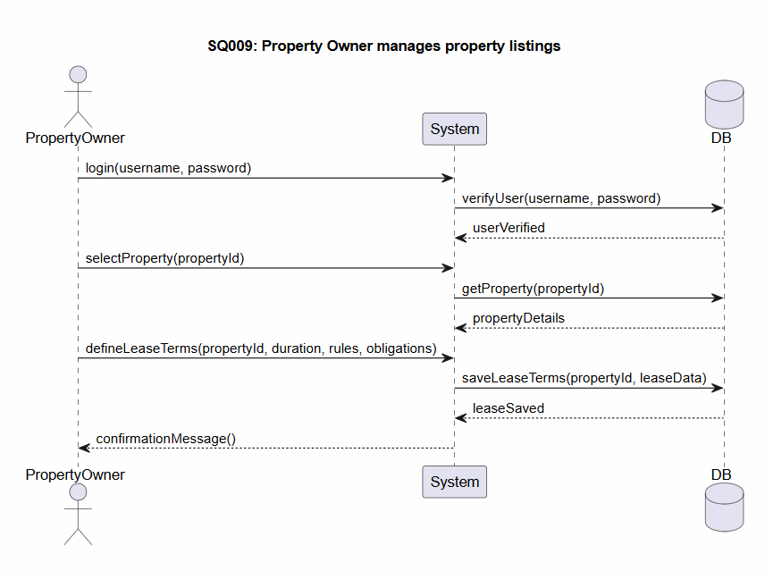

Sofika Mamillo

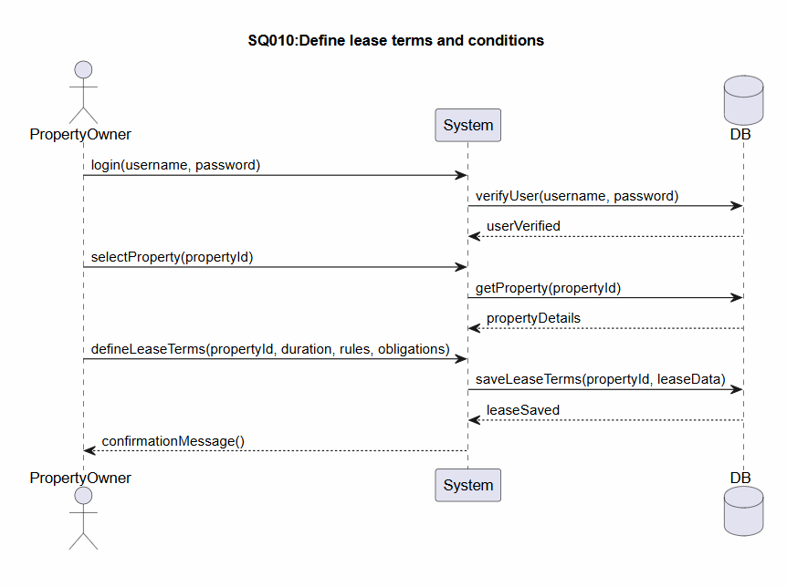

Sofika Mamillo

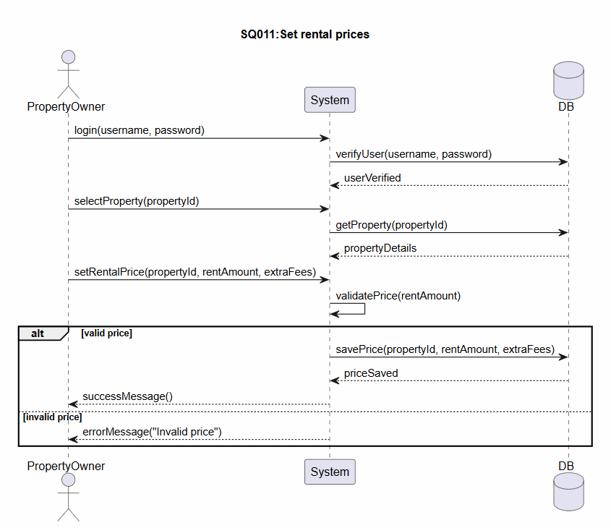

Sofika Mamillo

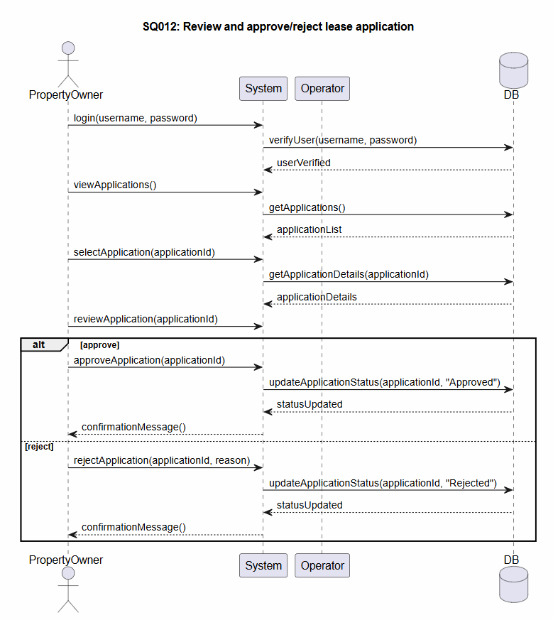

Sofika Mamillo

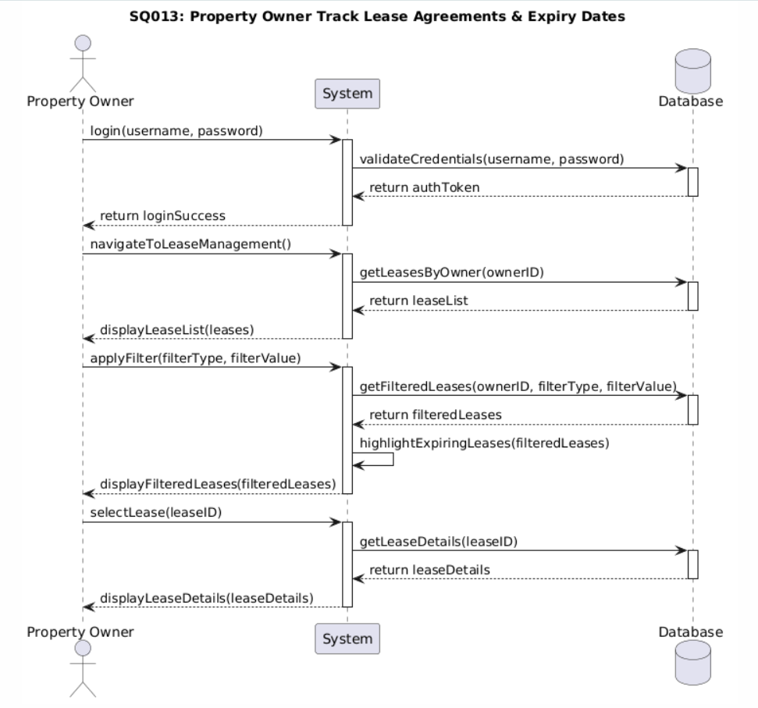

Redi Halidini

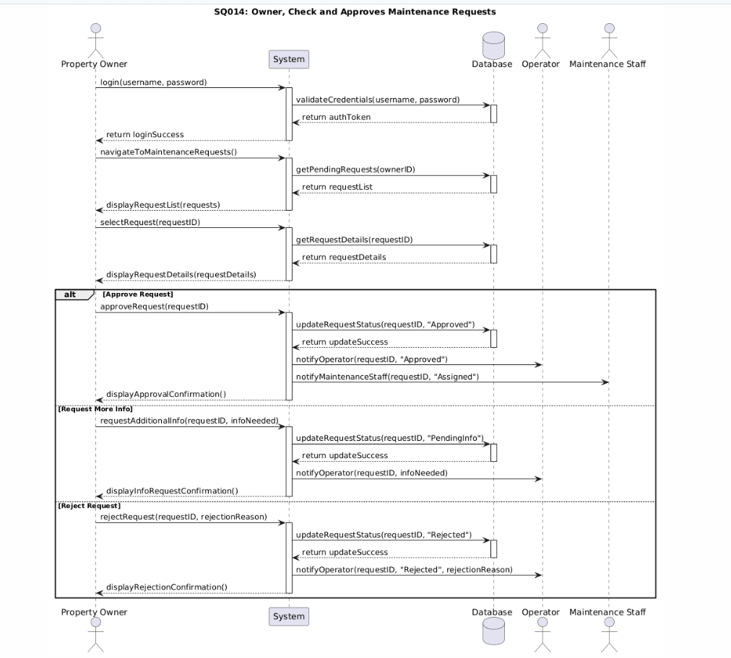
Redi Halidini

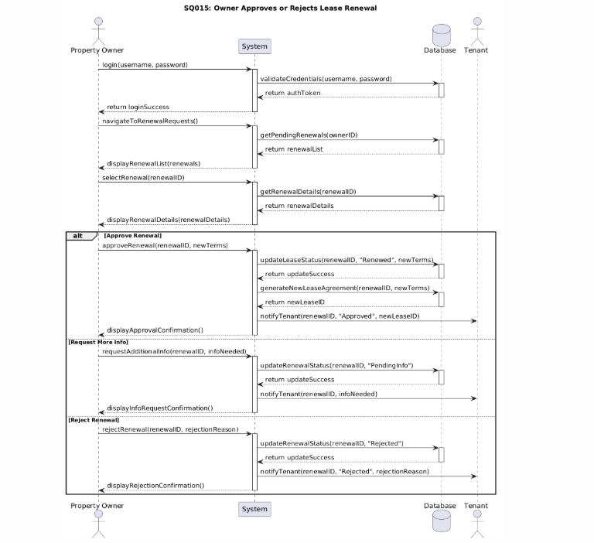

Redi Halidini

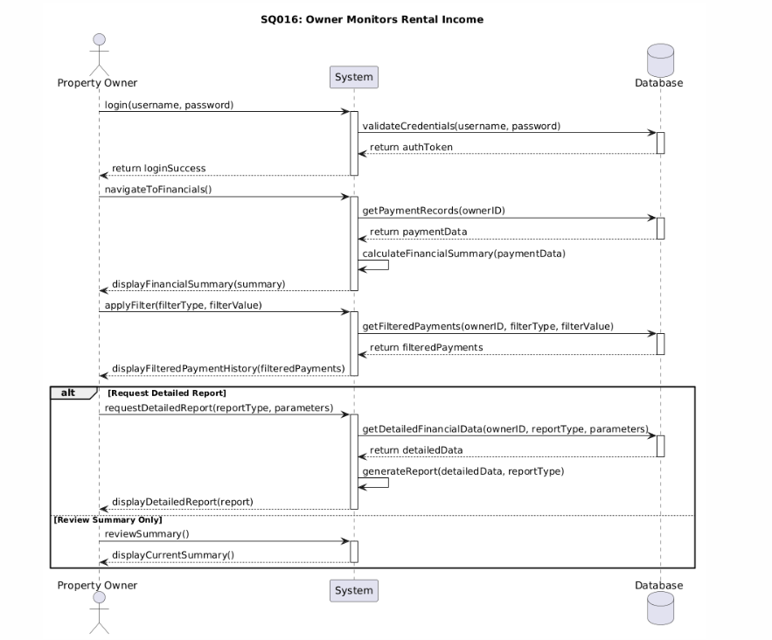

Redi Halidini

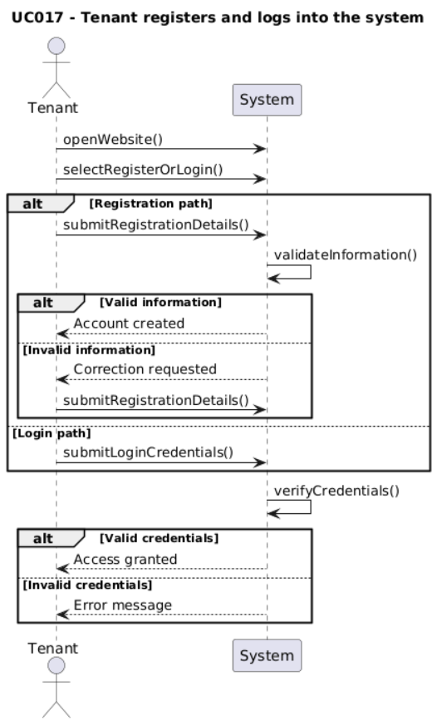

Kostandino Beko

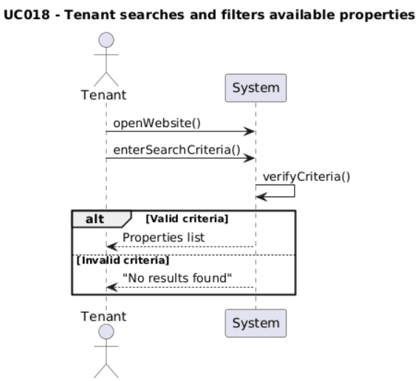

Kostandino Beko

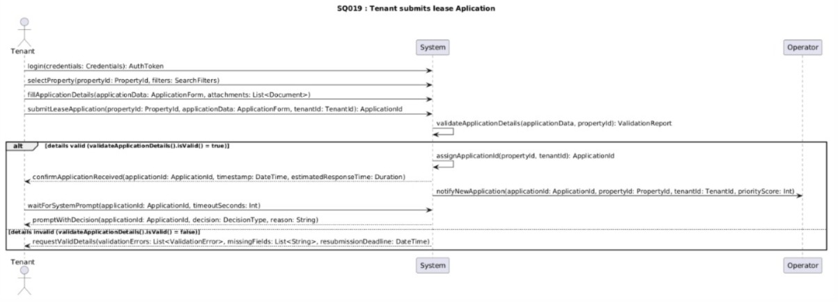

Najla Kuqi

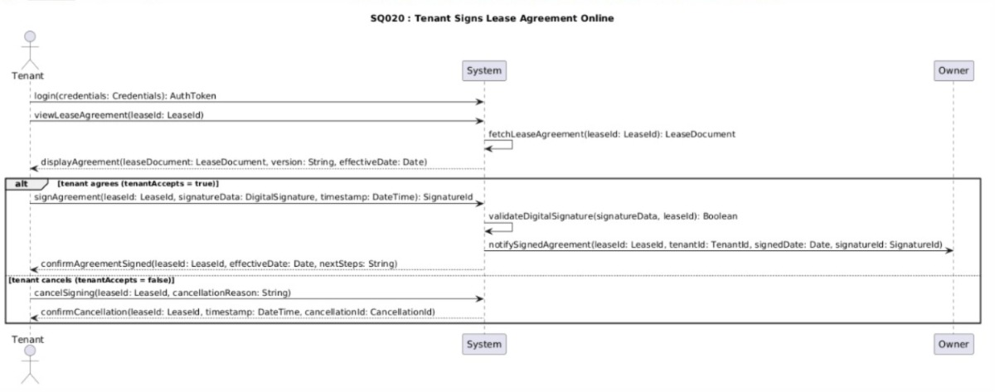
Najla Kuqi

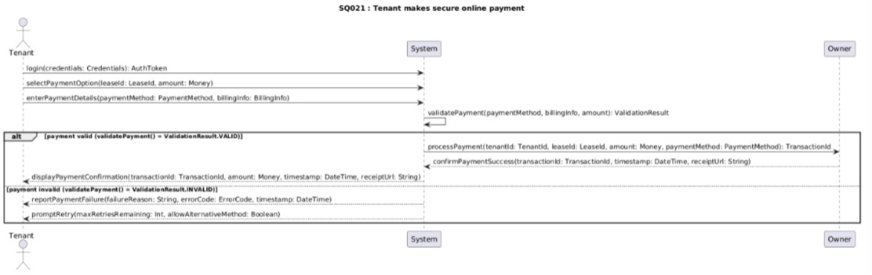

Najla Kuqi

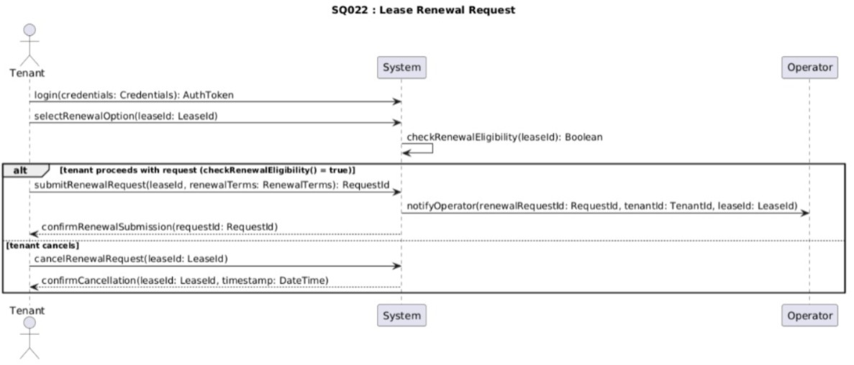

Najla Kuqi

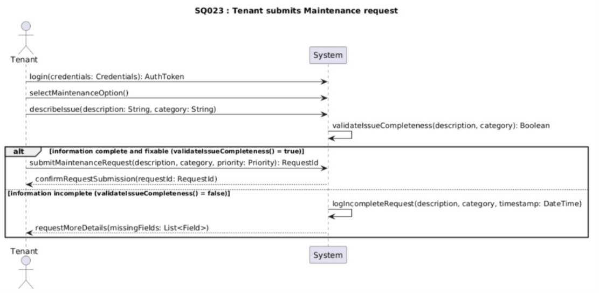
Najla Kuqi

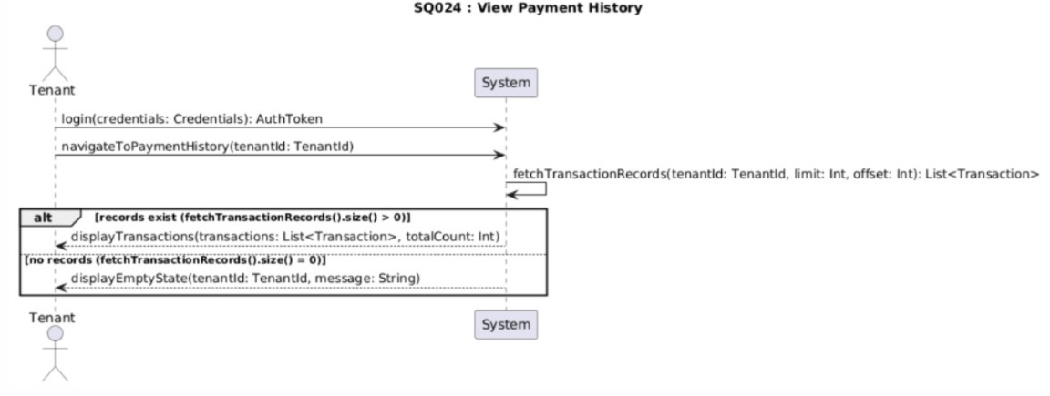
Najla Kuqi

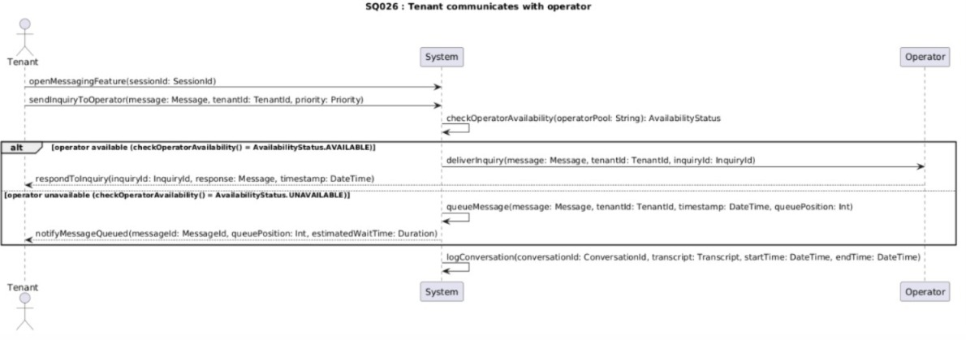

Najla Kuqi

SQ027:

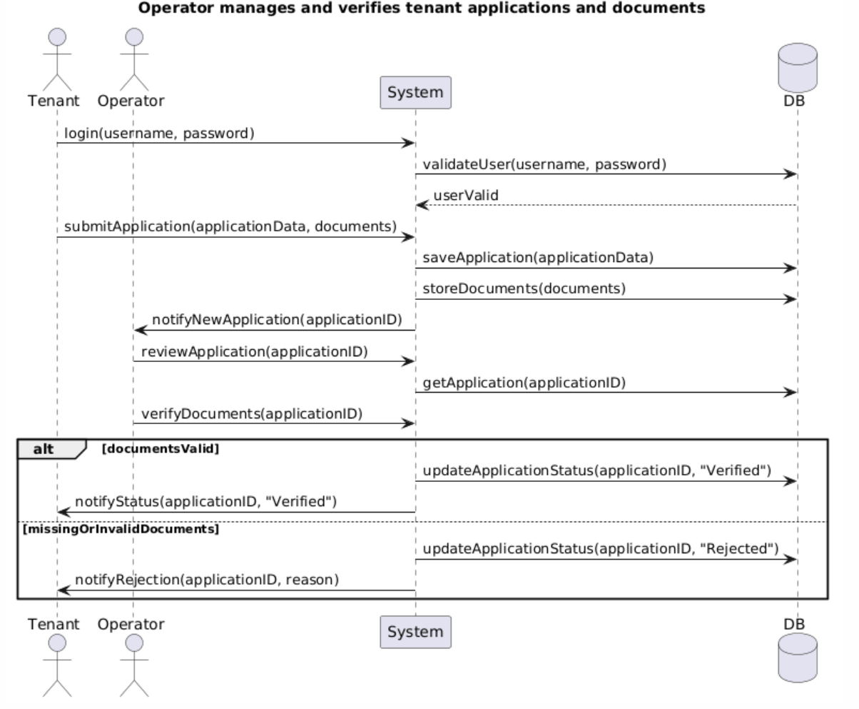

SQ028:
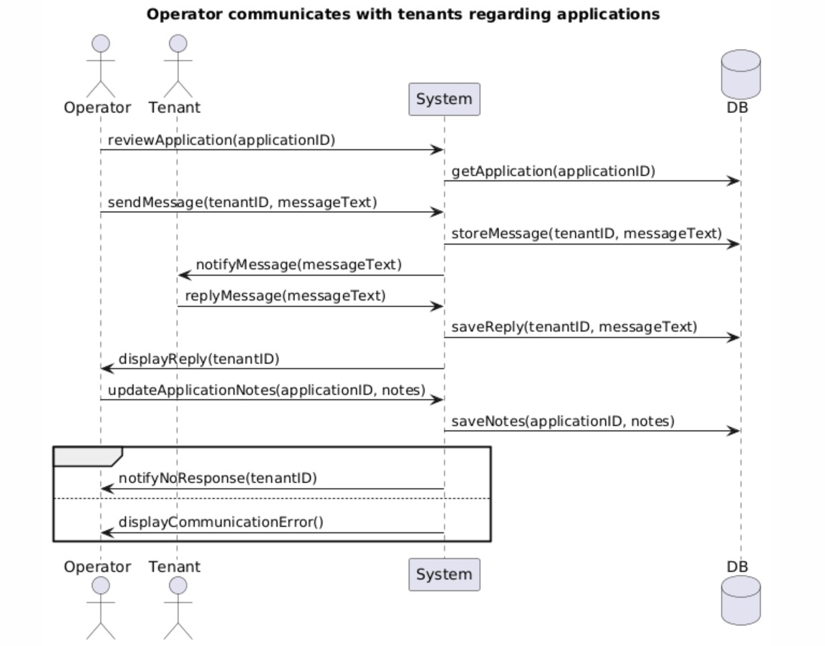
Kreisa Guce

SQ029:
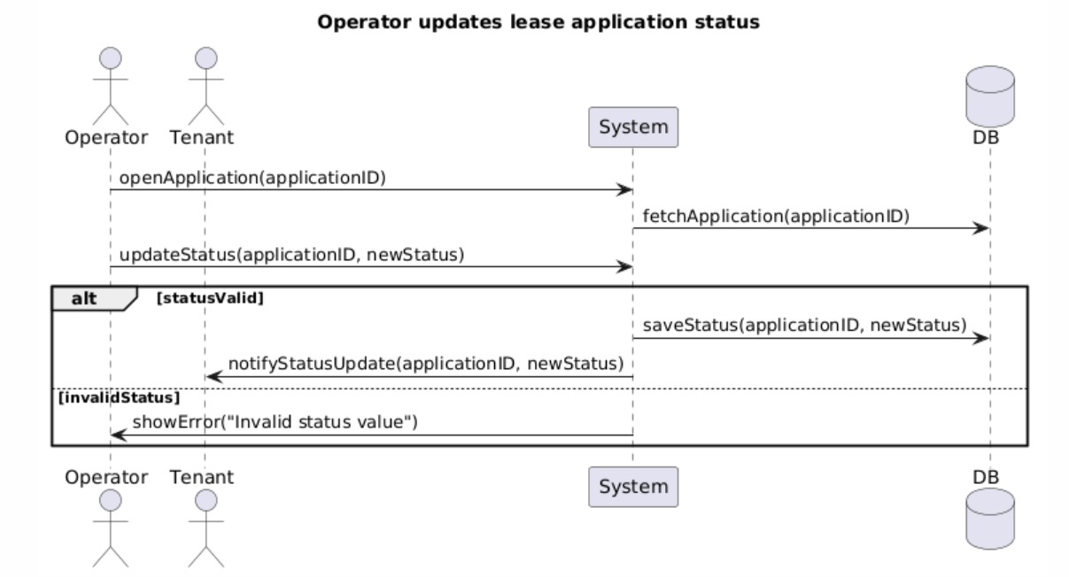
Kreisa Guce

SQ030:

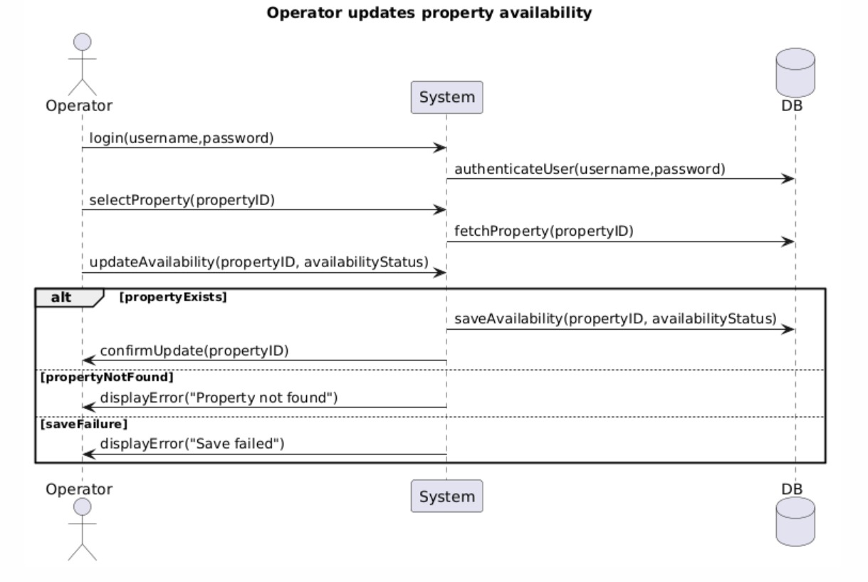

Kreisa Guce

SQ031:

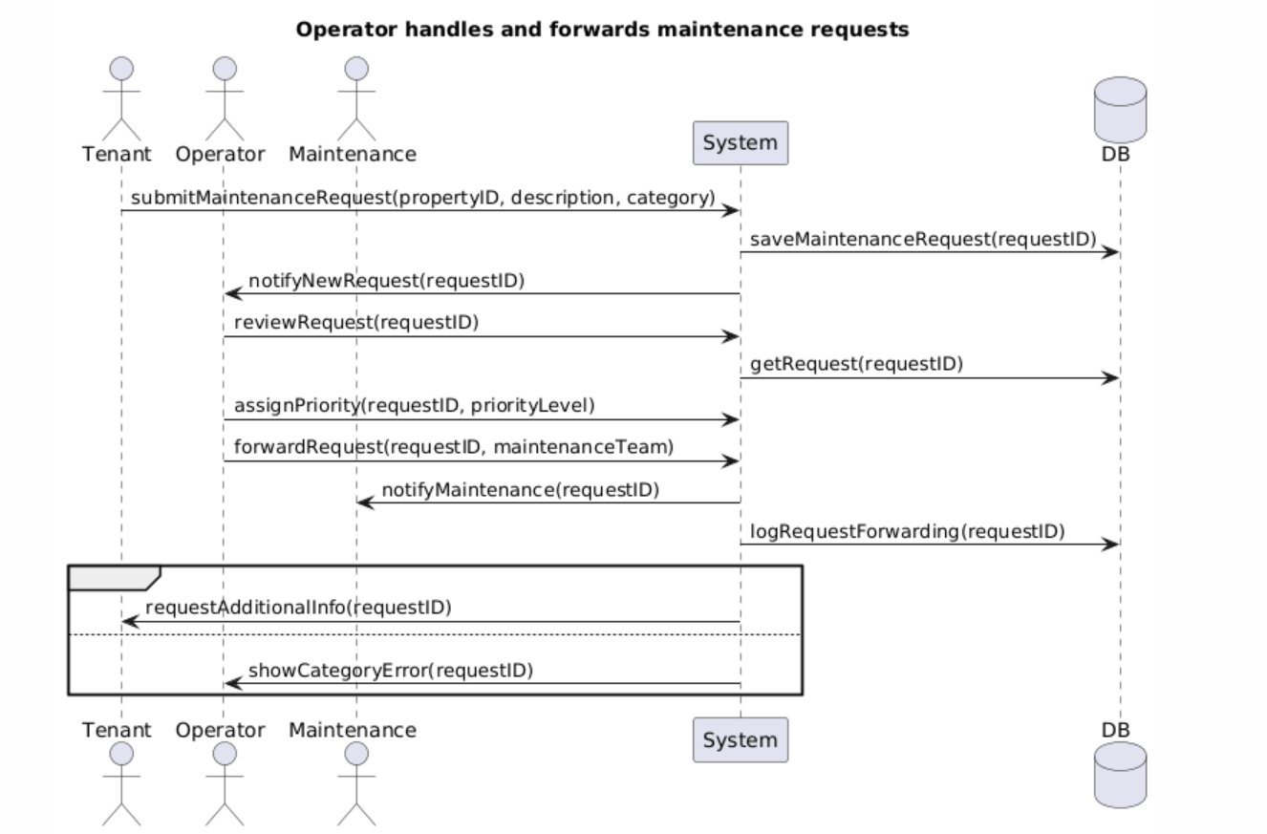
Kreisa Guce

SQ032:

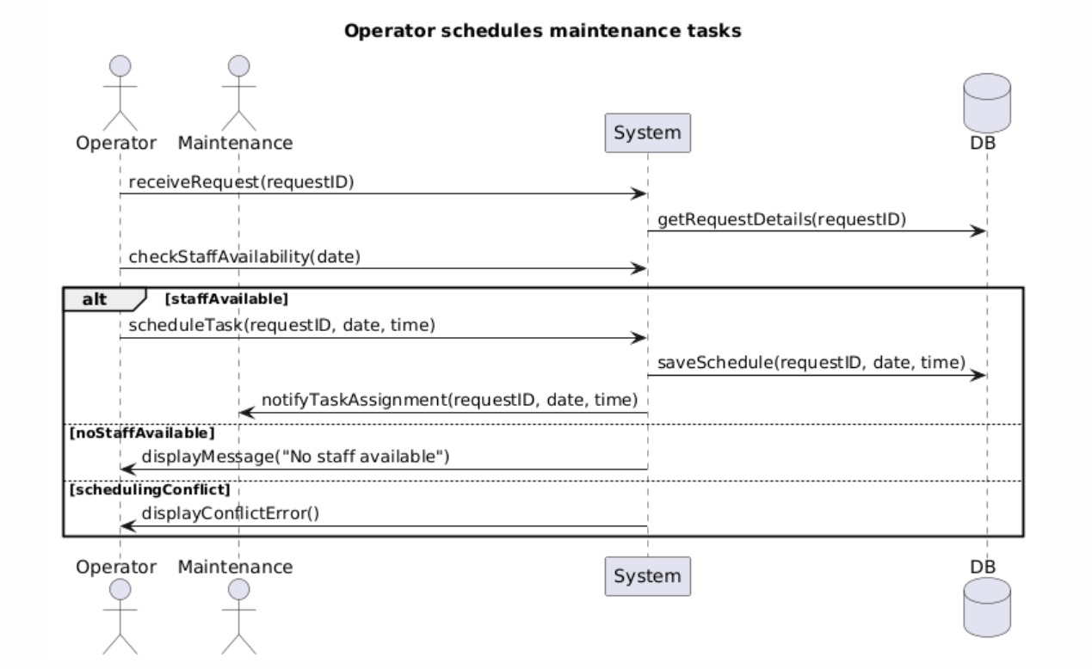

Kreisa Guce

SQ033:
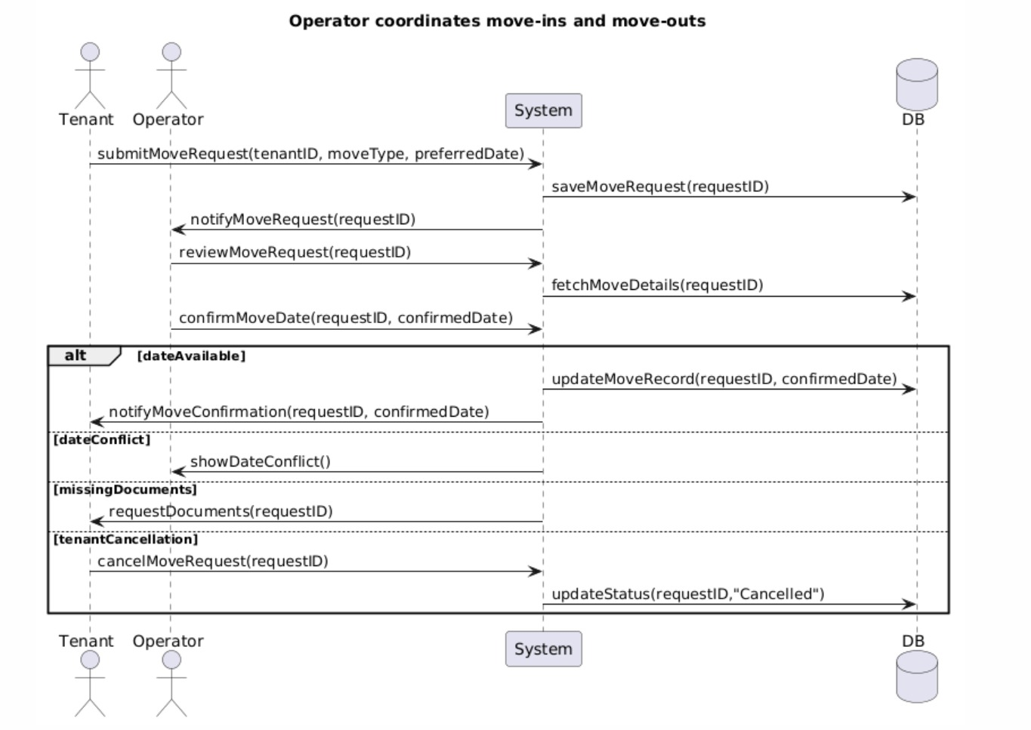
Kreisa Guce

SQ034: Manage Rent Payment Records
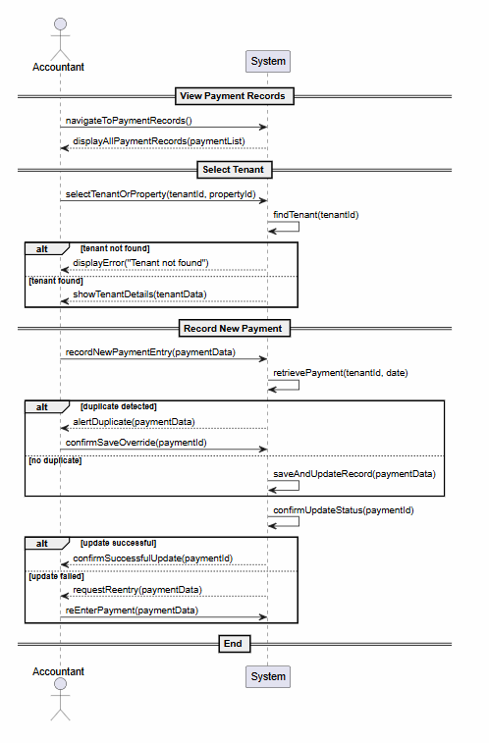
Greidi Muca
SQ035: Generate Invoices for Tenants
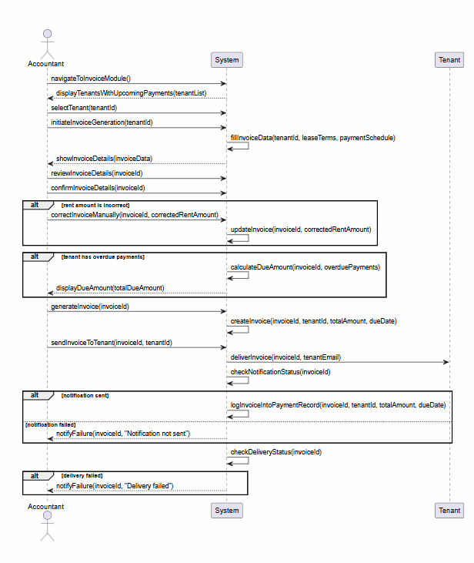
Greidi Muca

SQ036: Track Overdue Payments and Outstanding Balances
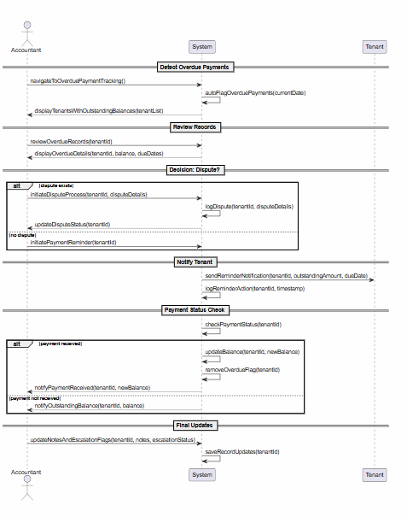
Greidi Muca

SQ037: Process Refunds and Manage Security Deposits
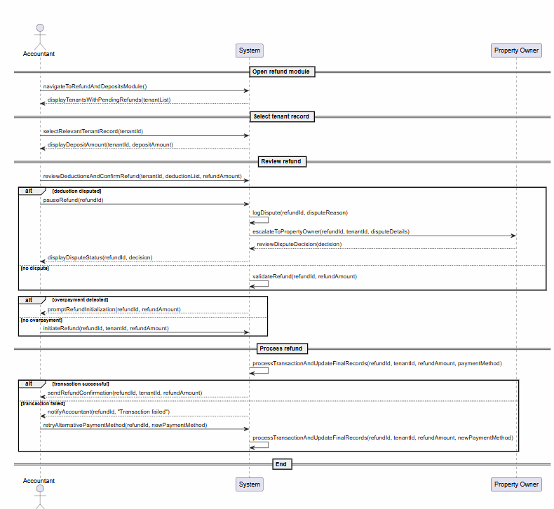
Greidi Muca

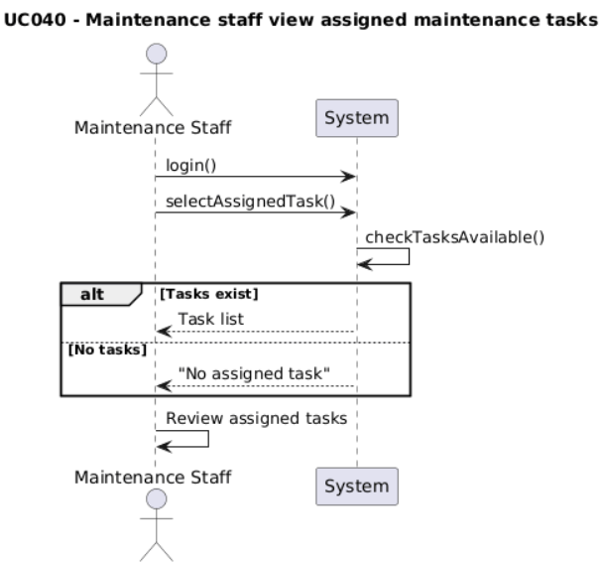
SQ038: Maintenance staff view assigned maintenance tasks.

Kostandino Beko

SQ039: Maintenance staff update task status
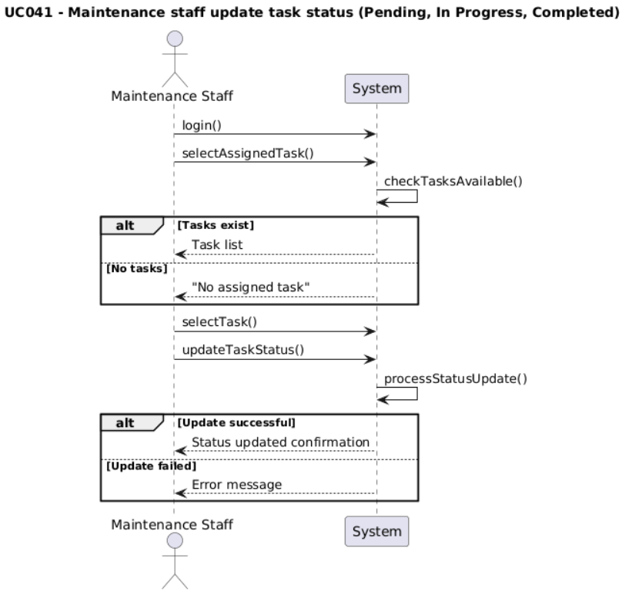

Kostandino Beko

SQ040: Maintenance staff perform repair, inspection, and property maintenance

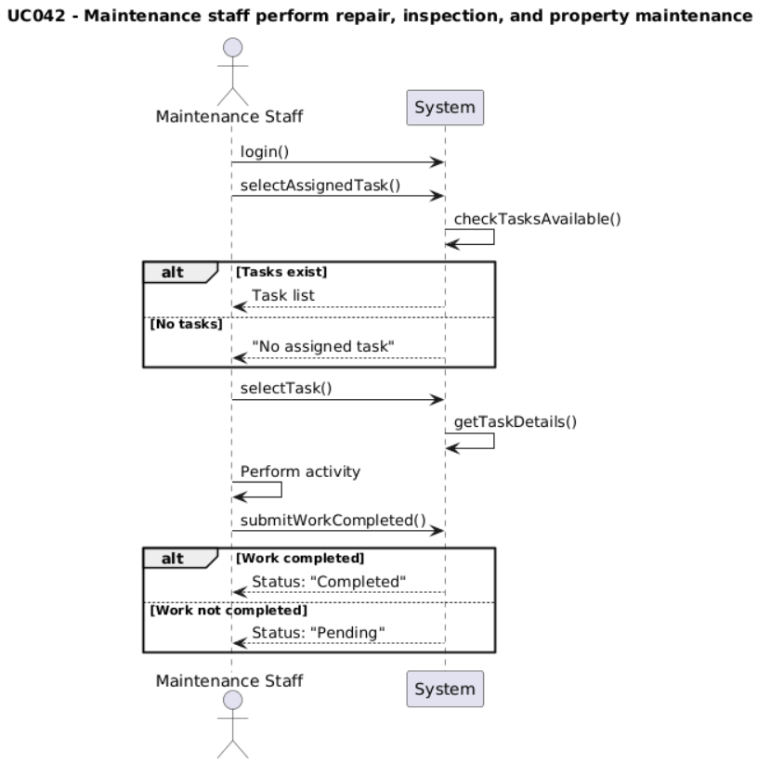

Kostandino Beko
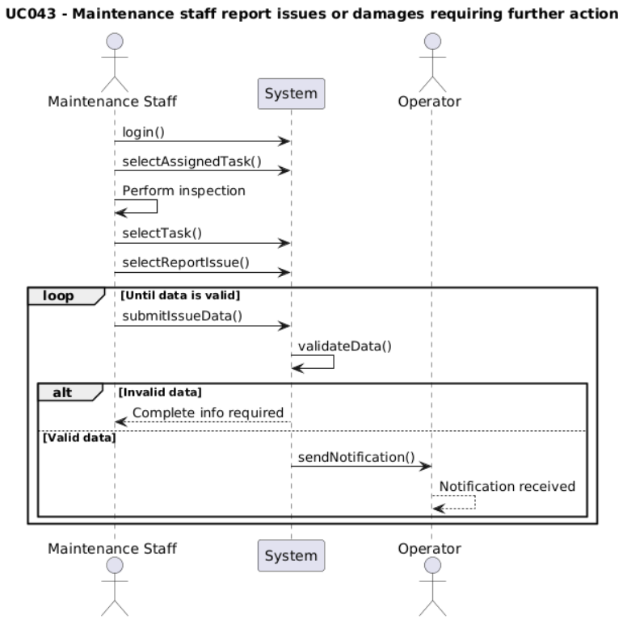
SQ041: Maintenance staff report issues or damages requiring further action.

SQ

Kostandino Beko

